**21)Aim:** To Design Deterministic Finite Automata using simulator to accept even number of a’s.

**Diagram:**

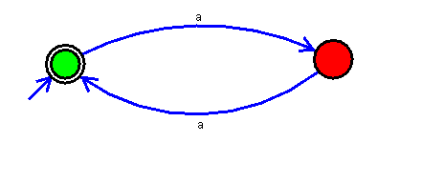

**Result:**

Thus, successfully executed Deterministic Finite Automata using simulator to accept even number of a’s.